RoamReady — UX Mockups
Locked design targets — companion to the written hand-off
Prepared by Cindy (UX) · May 20, 2026
One mockup per page. Each caption points to the matching section of the written hand-off doc (RoamReady_HandOff_Profile_Rig_Style_Memberships) so the spec and the visual target can be read side by side. Images are re-renders of the in-session mockups; small styling differences from the chat preview are cosmetic. Icons render as emoji where the icon font was unavailable offline.
Six locked screens follow.

1. Trip setup — “Are you bringing the F-150?”
Hand-off section 3 — Trip setup: “bringing this vehicle?”
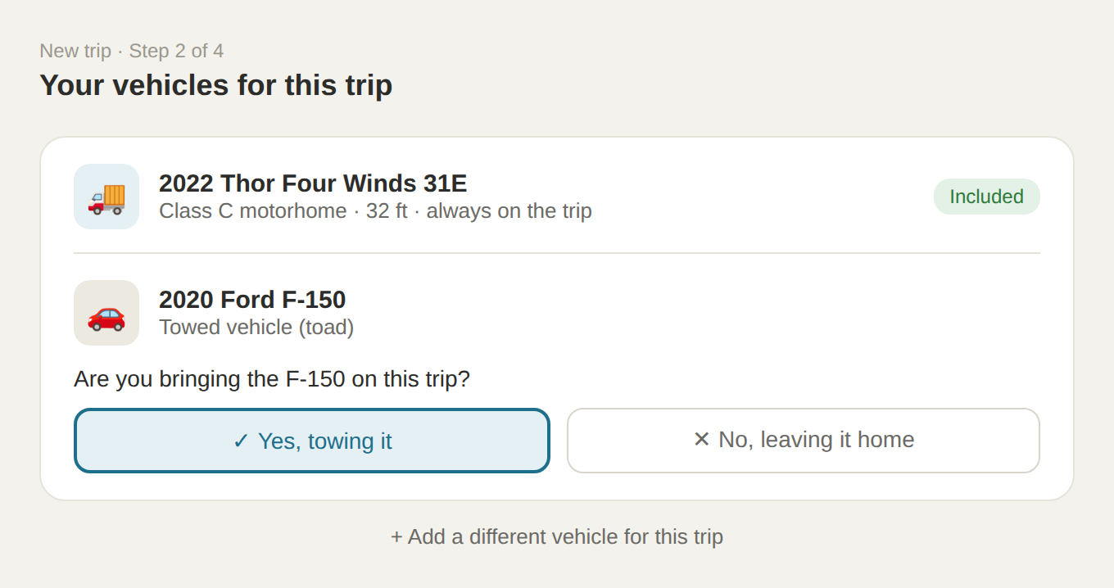
Notes: Appears only for a toad (optional). The rig shows as “Included” and is never a question; a required tow vehicle would also show as “Included.” The bottom link adds an ad-hoc, non-saved vehicle.

2. Rig profile — motorhome with toad
Hand-off section 2 — Rig / Vehicle: second-vehicle section
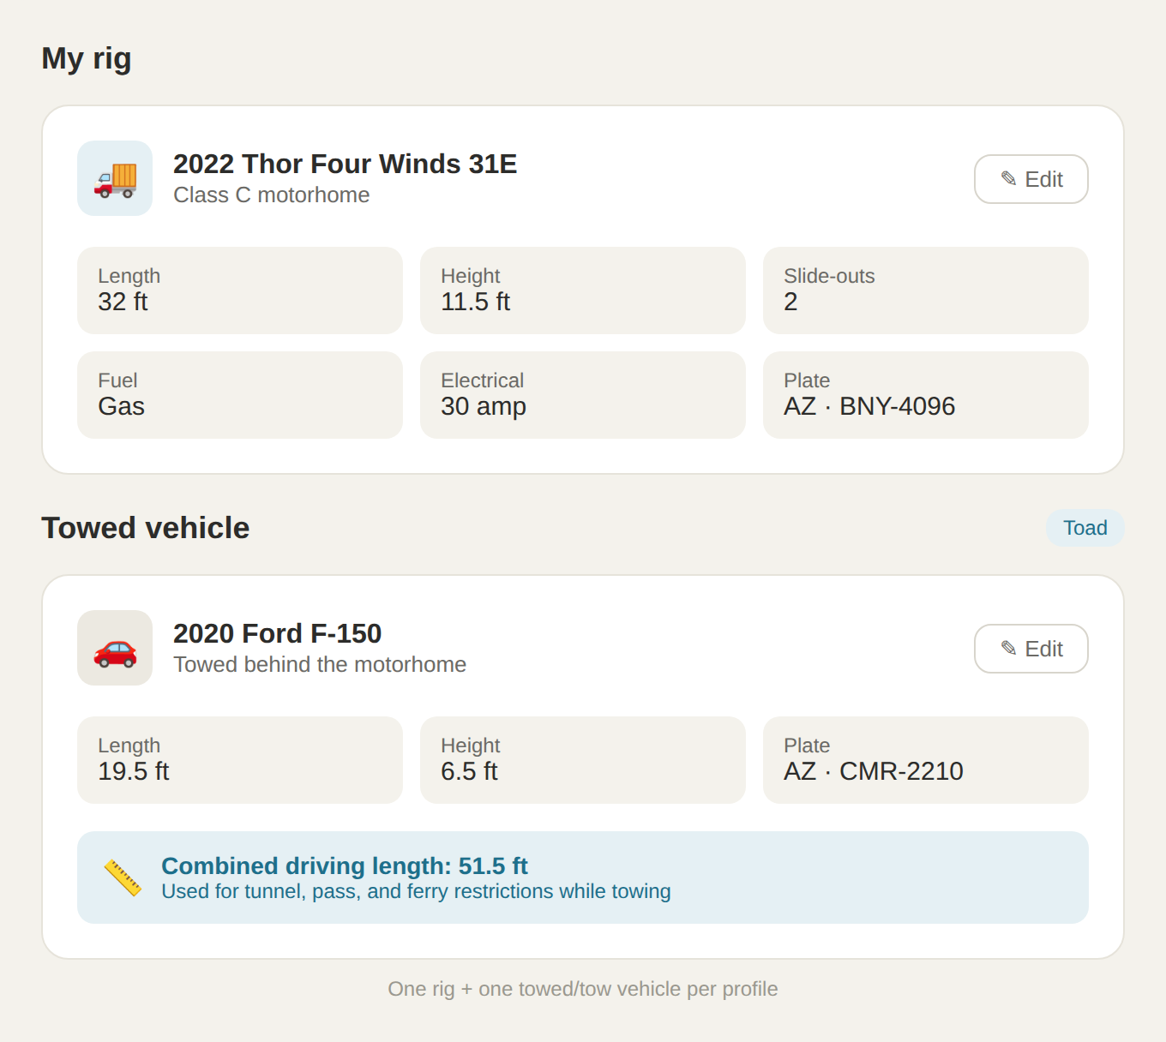
Notes: Two stacked cards. Toad variant: car icon, blue combined-length strip used for tunnel/pass/ferry restrictions only (a toad is unhooked at camp, so it does not affect site fit).

3. Rig profile — fifth wheel with tow vehicle
Hand-off section 2 — Rig / Vehicle: second-vehicle section
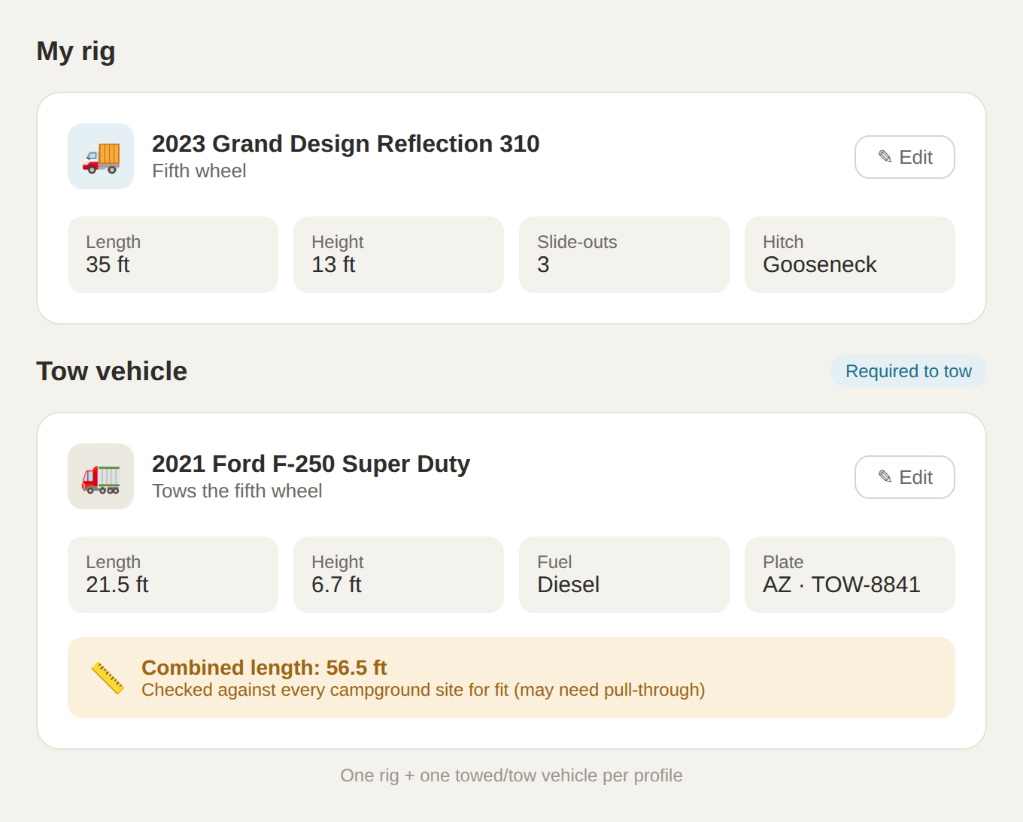
Notes: Same card, opposite direction. Tow-vehicle variant: truck icon, fuel field shown (diesel), amber combined-length strip — checked against every campground site for fit. Direction is set automatically by rig type.

4. Travel Style — interests, clean resting state
Hand-off section 4 — Travel Style: custom interests + clean state
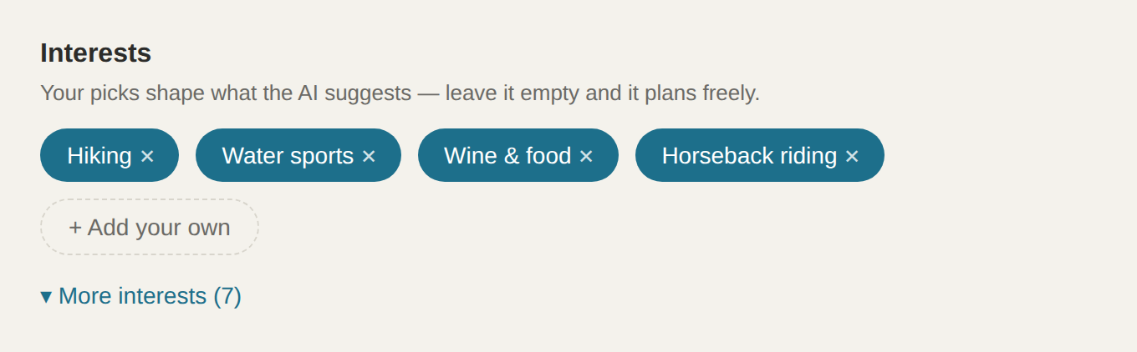
Notes: Resting state shows only selected + custom chips (“Horseback riding” is a custom add) plus “Add your own.” Unselected presets collapse behind “More interests (7).” New users see the full list expanded.

5. Memberships — AI per-stop choice card
Hand-off section 5 — Memberships: per-stop choice flow
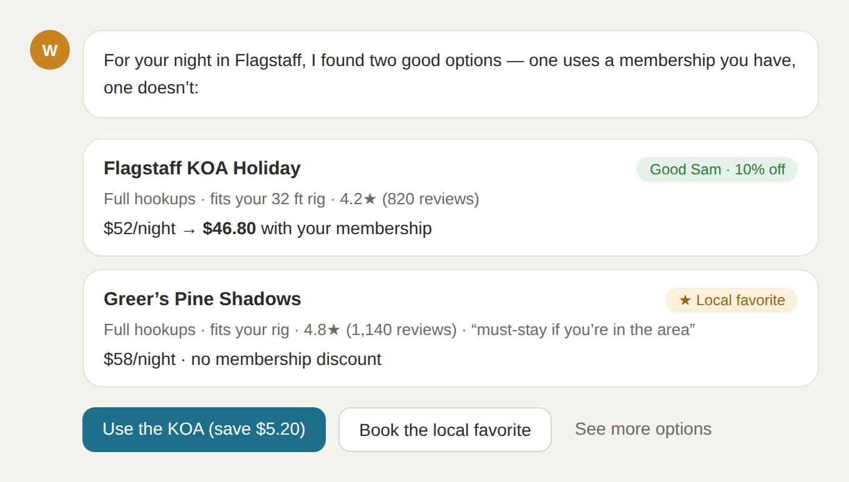
Notes: Opens when the user taps “Review options” on a stop. Presents the membership option (with savings) beside a higher-rated non-member option and lets the user choose. Memberships inform, never hard-lock.

6. Memberships — per-stop review on the built itinerary
Hand-off section 5 — Memberships: per-stop choice flow
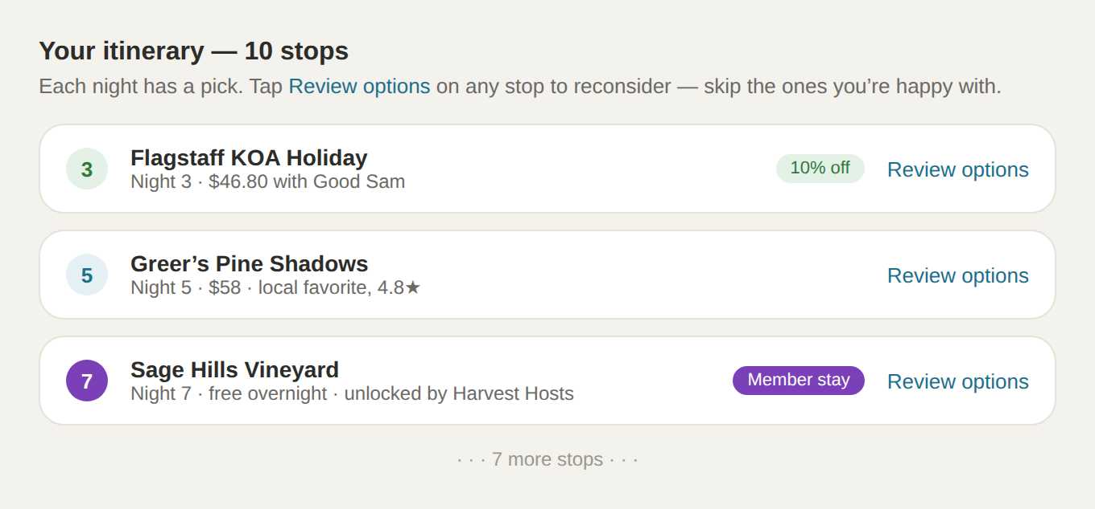
Notes: The post-build review pass. The itinerary is built first with smart defaults; each stop has “Review options.” Night 3 = discount membership (savings), Night 7 = network membership (a stay unlocked by Harvest Hosts).

